**OBJECT ORIENTED PROGRAMMING**

**FINAL PROJECT DESIGN DOCUMENT**

**COHORT A**

**PROJECT GROUP 7**

**LECTURER: DR DAVID EBO ADJEPON-YAMOAH**

**Project Title**

Surviving the Elements

**Authors**

1. Ben Charles Abdul
2. Laurik Houngninou Ifede Sandrine
3. Naa Lamiorkor Boye

**Introduction**

In our research on climate change, we realized that awareness of climate change and its effects had a positive correlation to actions taken to address climate change. The results of the study found a positive and strong association between climate change awareness and climate change adaptation (Abbasi & Nawaz, 2020). Thus, we decided to create a fun game which could educate people on the effects of climate by placing them in a world affected by climate change and letting them attempt to take steps to make a positive difference. Hence, educating them not only on the effects of climate but also on the various ways they can contribute to its solution.

*"Surviving the Elements"* is a text-based adventure game that aims to raise awareness and educate players about the impacts of climate change, as well as inspire them to take action to mitigate its effects. In the game, a player will navigate a world affected by climate change and make choices to reduce their carbon footprint and promote sustainability. The game will also incorporate the player’s personal lifestyle choices and actions to make it more relatable and applicable to their everyday life.

**Solution Design**

**CLASSES:**

* Player: represents the player of the game, including their name and inventory

Attributes: name (string), location (Environment), highscore (int), health (int)

Methods: move(void), useItem(item: Item), showInventory(String), getItem(item: Item), getHealth(int)

* Environment (abstract): represents the game world, including its locations and the impacts of climate change (e.g. flooding, drought)

Subclasses: Desert, Rainforest, Tropical, Temperate, Tundra

Attributes: averageTemperature (double), averageWaterLevel (double), environmentName(String)

Methods: getEnvironmentName(String), getAverageTemperature(double), getAverageWaterLevel(double), getQuestions(String)

* Item: contains information on different items the player can collect and use to mitigate climate change impacts (e.g. rain barrels, solar panels)

Attributes: name (String), effect (int)

Methods: getEffect(), getStatistics(), getName()

* Quest: creates the storyline and events of the game, including challenges the player must overcome to progress

Attributes: score (int)

Methods: getObstacle(), addPoints(points: int), subtractHealth(health: int), addHealth(health: int), subtractPoints(points: int), beginRound()

* UI: displays the game interface and allows the player to make choices and see their progress.

Functions for these classes might include methods to move the player between locations, collect and use items, and trigger events in the game. Inheritance would be used to create different types of environments that have different climate change impacts and require different mitigation strategies. Collections would be used to manage the player's inventory and the items available in the game.

**UML DIAGRAM:**

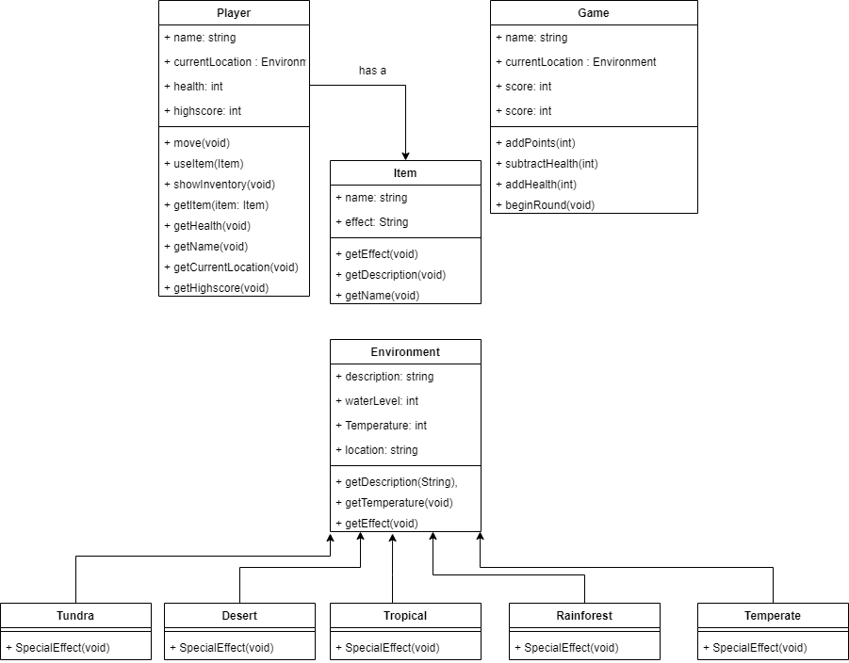

**Figure 1:** *A Unified Modeling Language diagram showing the various classes and how they are associated*

**REFERENCES**

Abbasi, Z. A. K., & Nawaz, A. (2020). Impact of climate change awareness on climate change adaptions and climate change adaptation issues. *Pakistan Journal of Agricultural Research*, *33*(3), 619.

*Temperate Zone - Definition, Characteristics, Solved Questions*. (2019, December 2). Toppr-guides. https://www.toppr.com/guides/chemistry/environmental-chemistry/temperate-zone/

*Sahara | Location, History, Map, Countries, Animals, & Facts*. (2023, April 20). Encyclopedia Britannica. https://www.britannica.com/place/Sahara-desert-Africa/Climate

The Editors of Encyclopaedia Britannica. (1998, July 20). *Rainforest | Definition, Plants, Map, & Facts*. Encyclopedia Britannica. https://www.britannica.com/science/rainforest

*The World’s Biomes:  Deserts*. (n.d.). https://ucmp.berkeley.edu/glossary/gloss5/biome/archive/deserts-old.html#:~:text=The%20extreme%20maximum%20ranges%20from,drop%20to%20%2D18%20degrees%20Celsius.

Wikipedia contributors. (2023a). Tropical climate. *Wikipedia*. https://en.wikipedia.org/wiki/Tropical_climate